

***Human Biology ATAR – Task 3: Extended Response***

***Lung diseases and treatments (7.5%)***

|  |  |  |  |
| --- | --- | --- | --- |
| Name: Danica Yutuc | | | |
| Time allowed: 1 Lessons | | | |
| **Section** | Your Mark | Marks available | Percentage |
| **Section 1:**  Report |  | 10 | 18.5% |
| **Section 2**:  Validation Test |  | 44 | 81.5% |
|  |  | **54** | **100%** |

**Declaration of Authenticity**

I (Student Name) _____________________ declare that this work is my own and I have not plagiarised from any source.

**Lung disease and treatments**

You are to choose **one** lung disease from List A and **one** disease from List B to research and find information about the named aspects of each disease. You will then complete an in-class validation assessment on your research without notes.

DISEASES

|  |  |
| --- | --- |
| **LIST A** | **LIST B** |
| Chronic bronchitis | Pneumonia |
| Emphysema | Pleurisy |
| Cystic fibrosis | Tuberculosis |

Check list

* Cause, or main causes
* Symptoms and diagnosis
* Current treatments…how they work and what they do
* Prevention

Write the names of the diseases you have chosen here:

Disease A______Cystic Fibrosis_______________________________

Disease B_______Tuberculosis______________________________

**Marks Table**

|  |  |  |  |  |  |  |
| --- | --- | --- | --- | --- | --- | --- |
| **Report** | **Cause** | **Symptoms** | **Treatments** | **Prevention** | **Marks** | Your mark |
| **Disease A** | 1 | 1 | 1 | 1 | 5 |  |
| **Disease B** | 1 | 1 | 1 | 1 | 5 |  |

TASK 3: Lung Disease

DUE DATE: 26 April 2023

This report will be covering two different types of lung diseases: Cystic fibrosis and Tuberculosis. This report will distinguish the cause, symptoms, diagnosis, current treatment and prevention for each type.

Cystic Fibrosis:

Cystic Fibrosis is a genetic disorder that primarily affects the lungs, but can also damage the pancreas, liver and intestines. It is caused by mutations in the cystic fibrosis transmembrane regulator (CFTR) gene, in which is responsible for controlling of salt and water in cells. It is also responsible for making proteins as it functions as a channel across the membrane that produce mucus, sweat, saliva and digestive enzymes. CFTR gene provides instructions for making CFTR proteins. Mucus are linings that protect airways, digestive tract and other organs and tissues. Mutations in CFTR gene will cause CFTR proteins to be inoperative. As a result, this causes a thick, sticky mucus and blockages in the lungs and possible inflammation that damages our organs. The mucus can block other parts of the digestive system which can affect how food travels through the stomach and how it is broken down and absorbed. CF mainly affects the pancreas, the secretion from the pancreas becomes thick that clog the ducts of the pancreas. This may cause a decrease in the secretion of enzymes from the pancreas that normally help digest food.

Symptoms:

* Fever
* Low body mass
* Sinuses infections
* Coughing that may produce mucus or blood
* Shortness of breath and frequent lung infections
* Poor growth or weight gain
* Abdominal pain
* Inflammation in pancreas
* Chronic constipation

Respiratory system complications:

* Damaged airways- makes harder to move air in and out of the lungs and clear mucus from bronchial tubes
* Chronic infections- thick mucus in the lungs results in sinus infections, bronchitis or pneumonia
* Coughing up blood- airway damaged
* Respiratory failure- CF can damage lung tissue which results in lung disease

Management of CF (lung problems):

* Physical therapy
* Regular exercises (to loosen mucus, stimulate coughing and improve overall physical condition
* Medicines to thin mucus and help breathing
* Antibiotics to treat infections
* Anti-inflammatory medicines

Digestive system complications:

* Diabetes- pancreas produces insulin, which your body needs to use sugar. CF increases risk of getting diabetes
* Liver disease- liver and gallbladder may be blocked or inflamed- lead liver problems
* Nutritional deficiencies- thick mucus can block the tubes that carry digestive enzymes from the pancreas to the intestines. No enzymes will result in no absorption of protein, fats or vitamins. This can result in malnutrition, delayed growth or weight loss

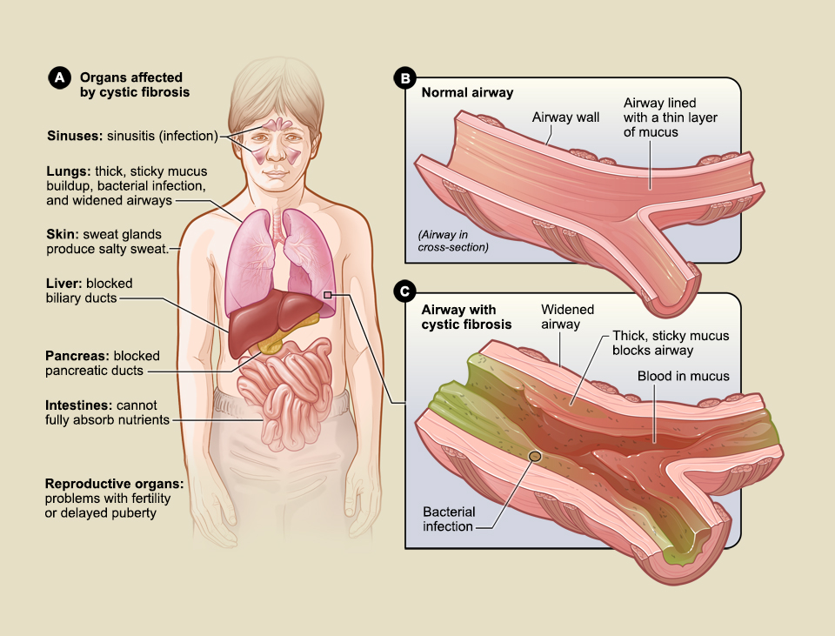

Figure A shows the organs that may be affected by cystic fibrosis. Figure B shows a normal airway and the thin layer of mucus lining the wall. Figure C shows an airway with cystic fibrosis. The widened airway is blocked by thick, sticky mucus that contains blood and bacteria.

Taken from: <https://www.nhlbi.nih.gov/health/cystic-fibrosis/symptoms>

If both parents carry faulty CF gene, it is then passed to a child. If each parent has normal CFTR gene and mutated CFTR each child has 25% inheriting two normal genes. 50% inheriting one normal and one mutated and being a cystic carrier. 25% inheriting two genes of mutations and having cystic fibrosis.

Treatment:

There is currently no cure for CF, but a range of treatments can help control the symptoms, prevent or reduce complications, and make the condition easier to live with.

Medicines for lung problems: People with CF may need to take different medicines to treat and prevent lung complications.

Medicines for lung disease:

* Antibiotics to prevent and treat chest infections
* Medicines to make the mucus in the lungs thinner
* Daily physiotherapy to clear the lungs,
* Bronchodilators to widen the airways and make breathing easier

Exercise:

* Any kind of physical activity: running, walking, swimming that can help clear mucus from the lungs and improve physical strength and overall health.

Airway clearance techniques:

A physiotherapist can also teach techniques to help keep the lungs and airways clear such as:

* The active cycle of breathing techniques- a cycle of deep breathing, coughing and relaxed breathing to move mucus
* Airway clearance devices- handheld devices that use breathing techniques, vibration and air pressure to remove mucus from the airways

Dietary and nutritional advice:

The pancreas often doesn't work properly, making it even harder to digest food.

A dietitian will advise on how to take extra calories and nutrients to avoid malnutrition

* They may recommend a high- calorie diet
* Vitamin and mineral supplements
* Digestive enzymes capsules with food to help with digestion

Lung transplants

In severe cases, when lungs stop working properly and all medical treatments have failed to help, lung transplant may be recommended

* A lung transplant is a serious operation that carries risks, but it can greatly improve the length and quality of life for people with severe cystic fibrosis

Diagnosis:

Diagnosis includes genetic screening to detect CF for carriers. Prenatal screening may be done during or before pregnancy to see if the unborn babies will have CF mutation gene and if they will also be a carrier. This is done using blood, saliva or cells to examine the DNA and to proceed in this test. If a child carries CF, it is important to diagnose early to prevent further complications. This is done by Newborn screening for babies 2-3 days old, where it begins with a blood sample to check for levels of a chemical made by the pancreas known as immunoreactive trypsinogen (IRT) where it is analysed in labs. Sweat test is also used to check high levels of chloride in our sweat. It is performed by applying a small amount of colourless, odourless chemical and a little electrical stimulation where it is applied to a small area of a person’s arm or leg. Sweat test is performed to check if CF will be positive, unclear of unlikely the table below presents sweat sample test result. If the level of chloride is less than 30 millimoles per litre (mmol/L), CF it is unlikely for someone to have CF. 30 to 59 mmol/L chloride level indicates that a diagnosis of CF is unclear and need further testing. A chloride level of 60 or greater indicates cystic fibrosis.

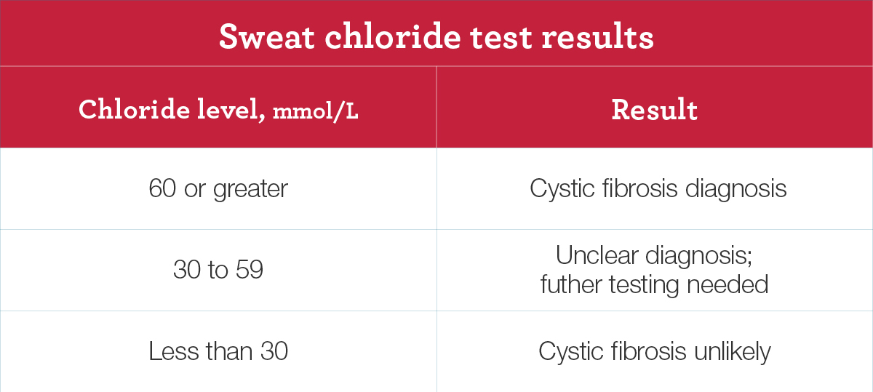

Image from: <https://www.nhlbi.nih.gov/health/cystic-fibrosis/diagnosis>

Prevention:

In babies with two abnormal CF genes, the disease is already present at birth in some organs such as pancreas and liver, but it develops only after birth in the lungs. CF is currently unpreventable; however, gene therapy can be used to treat lung disease from developing. Gene therapy is a technique that modifies a person’s genes to treat or cure the disease.

Tuberculosis:

Tuberculosis (TB) is a bacterial infection caused by Mycobacterium tuberculosis that primarily damages the lungs. It is a contagious disease that easily spreads through the air when a person coughs or sneezes and infects other people. The disease is more likely to spread when people spend a lot of time in an indoor space, crowded gatherings, people who recently returned from countries with a high number of TB cases and close contact with a person with TB disease in the lungs. There are two types of TB including Latent TB infection, where someone is exposed to TB but does not get sick as their immune system can fight and control the infection. Active TB disease develops when bacteria multiply and the body’s immune system is unable to manage where your body is exposed to a wide range of symptoms.

A TB infection occurs when microorganisms persist, develop and can take in one of the following stages. Primary TB infection is the initial stage in which the immune system detects and captures bacteria with the goal to eliminate them and potentially prevent them from growing, reducing the risk of the immune system from weakening and affecting the lungs. This stages symptom includes low temperature, fatigue and a cough. Infection with latent TB occurs when the immune system builds a wall around a tissue in the lungs containing the bacteria that cause TB. They won’t experience symptoms in this stage if the immune system can keep the germs under control and it won’t do any harm to the body. Active TB disease stage where it takes place outside of the lungs. Extrapulmonary tuberculosis is where a TB infection can spread from the lungs to other parts of the body. Symptoms of an active TB stage include fever, chills, night sweats, weight loss, loss of appetite and tiredness. However, symptoms can vary depending on what part of the body is infected. Severe symptoms include difficulty breathing, coughing up blood, blood in your urine or stool and chest pain that is why it is important to get immediate and urgent care. Common sites of TB disease outside the lungs include kidneys, liver, heart muscle, fluid surrounding the brain and spinal cord, lymph nodes, skin, walls of blood vessels or larynx. A person with a weak immune system will have a higher chance of being exposed to the risk of getting active TB.

Conditions that involve diabetes, severe kidney disease, malnutrition, smoking and consumption of alcohol all enhance the risk of TB infection for active TB disease to take place.

Treatments:

Latent TB can be treated with antibiotics for 3 to 6 months in order to minimise the chance of developing active TB. Preventative therapy involves eliminating microorganism that could trigger problems if the disease becomes active. A daily dose of the antibiotic isoniazid (INH) is taken every day. Active TB is treated with a combination of antibacterial medications for six to 12 months. The most common treatment for active TB is isoniazid INH in combination with three other drugs (such as rifampin, pyrazinamide and ethambutol). They must complete the entire course of medication, or it can also lead to drug-resistant TB. Drug-Resistant TB means that some drugs used to treat TB will no longer be able to prevent it from spreading and the severity of the disease. TB that is resistant to more than one drug, called multidrug-resistant TB is very dangerous and could last 20-30 months to complete and may experience some side effects.

Side effects of medication may include:

* Vomiting
* Changes in visions
* Loss of appetite
* Sadness or depression
* Yellowish skin or eye colour
* Dark urine
* Rash
* Unexplained weight loss and tiredness
* Easy bruising or bleeding

Diagnosed:

* Skin testing where a small amount of liquid protein is injected just under the top layer of the skin it is also known as the Mantoux Test. After 48-72 hours if there is a red lump, it means that you have been infected with TB.
* A blood test can also detect TB. These tests won’t be straightforward and won’t tell if you have latent or active.
* Molecular test to detect the bacteria’s genetic material and help identify which antibiotics will work best.
* Bone scans can be used to tell the difference between cancerous lesions and those caused by TB.
* Further testing may be carried out such as x-rays (to show whether TB has affected the lungs), physical examination or a sputum culture to see if you have active TB or latent TB and to show if there are bacteria present in mucous coughed up from the lungs.
* Sputum test- your health care provider may take a sample of the mucus that comes up when you cough, also called sputum. If you have active TB disease in your lungs or voice box, lab tests can detect the bacteria

Prevention:

Prevention can be done by a vaccine called bacilli Calmette-Guerin (BCG). However, it does not prevent TB, but it will help to minimise and prevent severe TB disease and will protect children from getting TB. To minimise the spread of TB these following actions must be performed.

Prevention can be done by a vaccine called bacilli Calmette-Guerin (BCG). However, it does not prevent TB, but it will help to minimise and prevent severe TB disease and will protect children from getting TB. To minimise the spread of TB these following actions must be performed.

1. Always cover your mouth with a tissue when coughing or sneezing and immediately throw it away
2. Wash your hands after coughing or sneezing
3. Stay home from work, school or other public places
4. Don't use public transportation
5. Take all your medicines as they're prescribed and keep all your doctor’s appointments
6. Eliminate bacteria around the house by an open window to get fresh and clean air
7. Don't travel across the country, to eliminate the spread of TB bacteria and to not affect other people.

Bibliography:

<https://www.mayoclinic.org/diseases-conditions/tuberculosis/symptoms-causes/syc-20351250>

<https://www.healthdirect.gov.au/tuberculosis#symptoms>